Tutorial One

Introduction to virtual box and kali Linux

Welcome to the fist tutorial of the society, hopefully this will all be the same as the computers in the lab as I am making this at home. If there are any problems notify me and I will update the document.

Step one is to open virtual box. This will be the program used to virtualise the kali Linux machines we will be using for most of the topics we will be covering. Once you have opened virtual box you should see something like this.

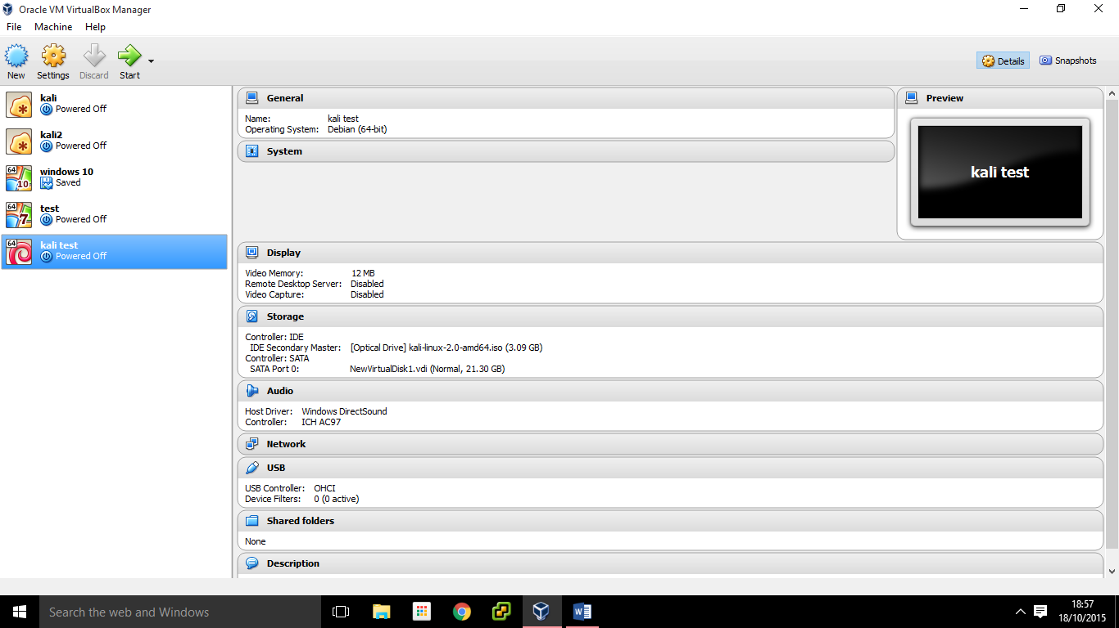

Hopefully I will have already set the kali Linux image up so you should just have to click on it and hit start. For me it is kali test so I will click start on that one.

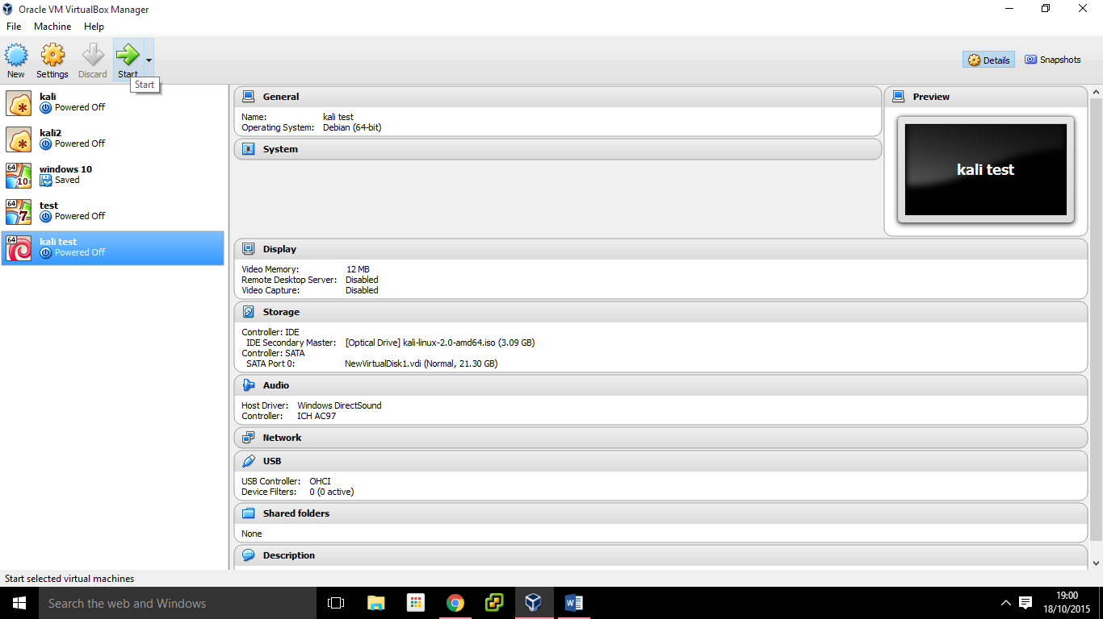

Once it has finished loading you should be greated with this menu chose the first option by pressing enter.

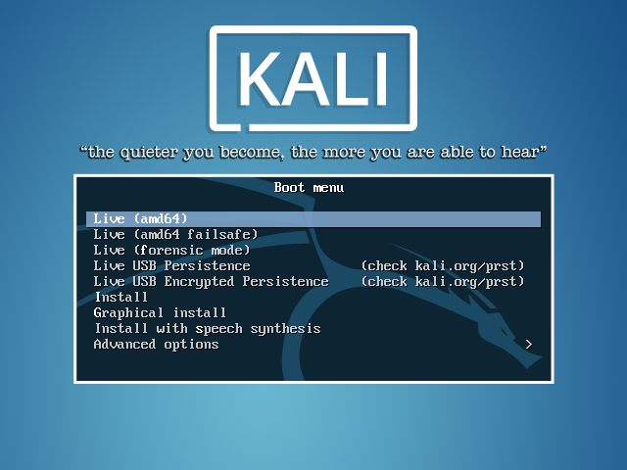

This option runs the machine without having to install kali onto the hard drive, meaning once you shut the virtual machine down all the data will be erased. The install option will allow you to install kali onto a physical hard drive in the machine or a virtual hard drive that virtual box can make, but we won’t need to save anything so we have opted for the live option.

Once kali has finished loading you should see the desktop. Kali is like any other Linux machine. Its default browser is Iceweasel. (Note: There is no internet in this lab. We will use the browser only for viewing our own webservers)

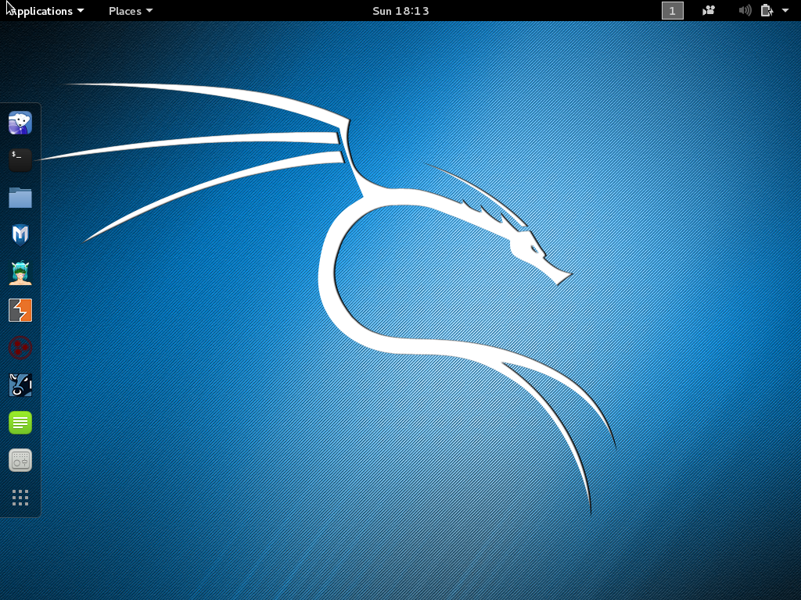 Web browser

 Comand terminal

 File browser

You will find the above icons on the left hand side bar. Click on the terminal icon so we can do some basic linux comands.

Once you have opend the terminal you should see this box.

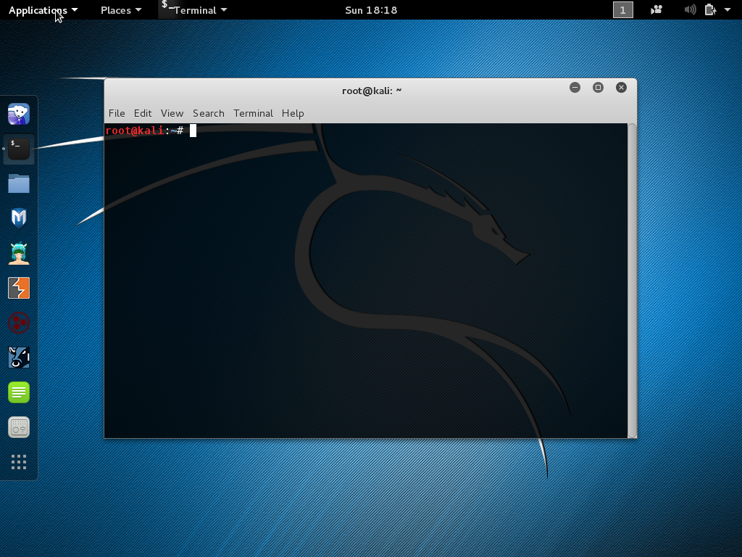

This is the kali terminal that will let you enter commands and use the tools that come with Kali. Note: root@Kali this means we are logged in as the root user; the windows equivalent to this would be the administrator account. Most Linux versions will not let you log in as the root user, instead you create a password for the root user and enter sudo (super user do) before a command that needs root privileges and enter the root password. Kali however does allow you to log in as the root user so sudo is not needed. However if you ever create a Linux machine or set one up it is advised not to use root as you can easily delete key files necessary for the system to run with no “are you sure” prompt in most cases.

If you get logged out the username is root and the password is toor (root backwards)

Let’s do our fist Linux command to find the IP address of our Kali machine. Type ifconfig and press enter (Note: on a windows machine it is ipconfig but on Linux it is ifconfig)

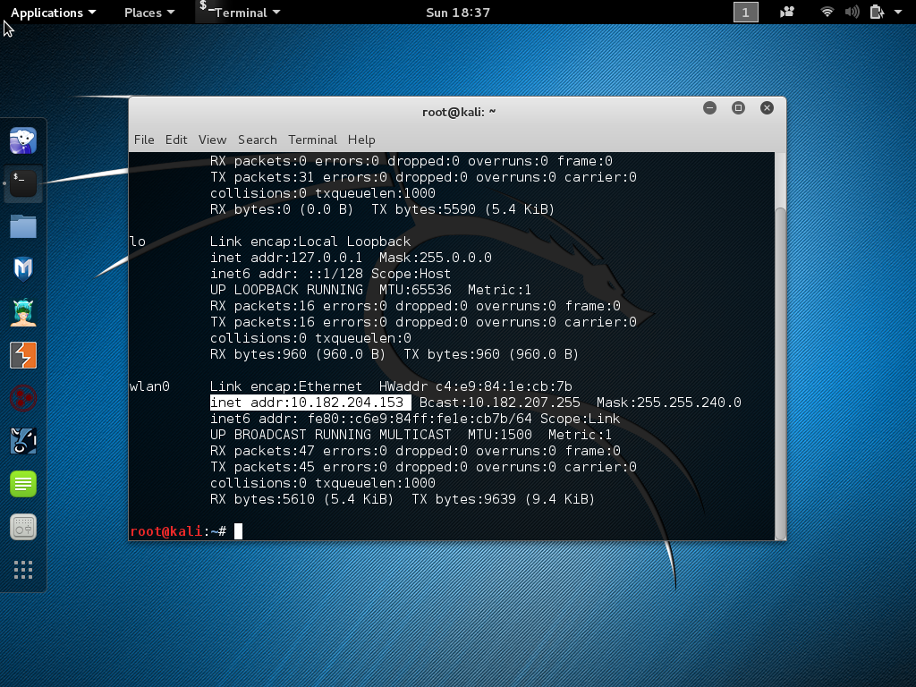

The above shows what I get when I enter ifconfig. (Note this will look different for every machine, mine has a lot of text as it picks up all the interfaces my laptop has the lab computers will likely only have one so don’t panic if it looks different to what you have). If you look at wlan0 I have highlighted the inet addr: 10.182.204.153. This is the IP address given to my wireless adapter. Your address will likely start with 192 and so on. We can clear this text by typing clear and hitting enter.

Next let’s see what files are in the current directory by typing “ls”. This should list the files and folders in the directory we are in.

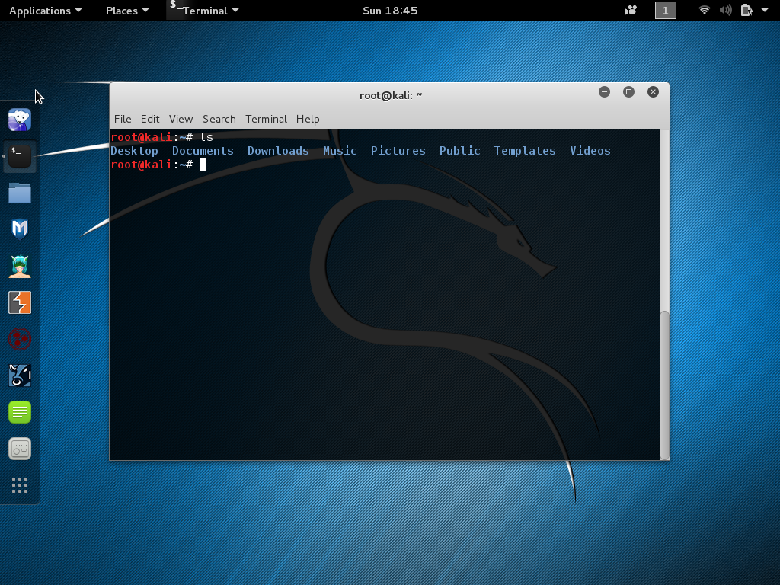

The result of typing “ls”. As with most command line tools, there are various “flags” that serve different purposes. For example, if you wanted to list the contents of all the subdirectories in a directory you can use “ls –R”. You can find a list of these flags by typing “ls –help”. If we click on the file icon on the left hand side we will see that the folders listed in the terminal are the same as the home directory.

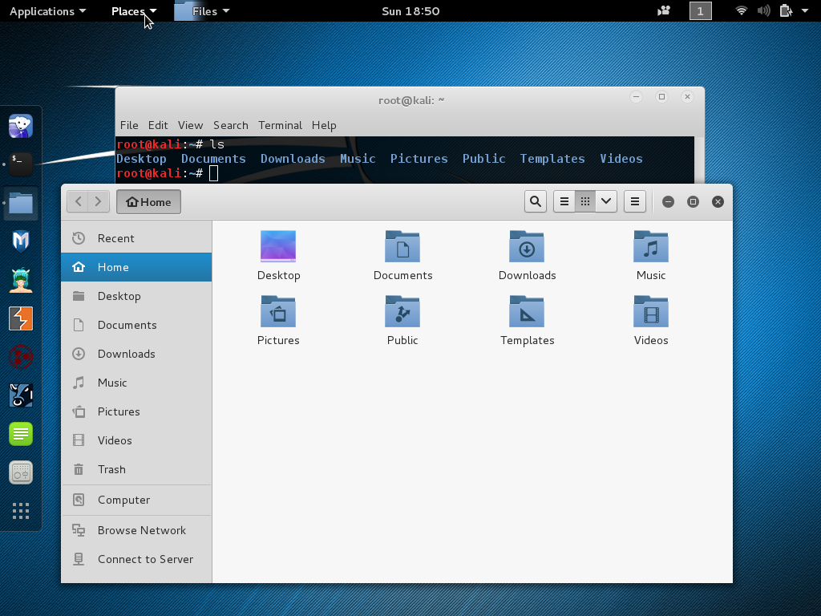

If we go back to the terminal and enter cd (for change directory) and take a space and enter Documents we should change to the Documents directory. (Note: if you get an error “no such file or directory” you haven’t used a capital D for documents. Linux is case sensitive)

You should now see that the root@Kali will now also have /Documents. This tells us that we are in the documents directory. Let’s create directory called Cyber in the documents directory by entering mkdir (for make directory) and Cyber to name the new directory Cyber. If you have done it correctly you will not get any acknowledgement for the terminal to tell you the directory has been made. To check, enter ls as before to see the directories and files in the Documents directory. Cyber should be there to enter the Cyber directory enter cd Cyber. The terminal should now say Documents/Cyber to tell us we are in the Cyber directory.

Let’s make a file in the Cyber directory by entering nano and pressing enter. (nano is a text editor)

Once you have entered nano you should see this.

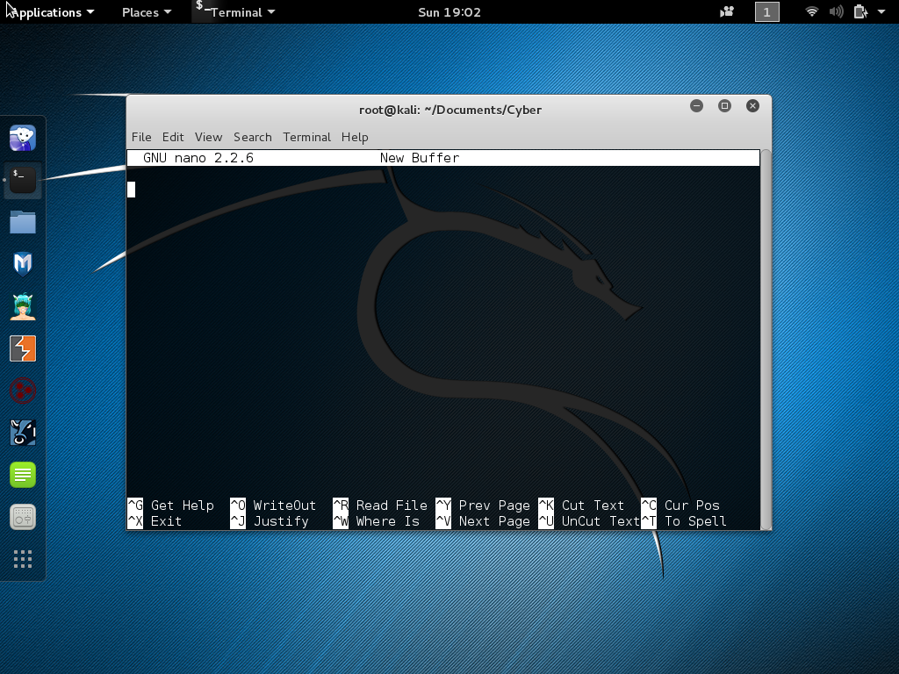

Type whatever you want to be the content of the file. To save the file press ctrl and x and then Y to save and name the file testfile. Now enter ls to see if the file shows up in the Cyber directory. Now go to the file manager again and navigate through Documents and then Cyber. The Test file should be there click to open it. Your text should appear. You now know how to navigate through the Kali Linux filesystem and create text files using nano.

Other useful command line tools:

**mv**

mv is used to move and rename files. Here are some examples:

Move main.c def.h files to /home/usr/rapid/ directory:

$ mv main.c def.h /home/usr/rapid/

Rename file main.c to main.bak:

$ mv main.c main.bak

Move all C files in current directory to subdirectorybak:

$ mv *.c bak

**Cat**

Cat is used to display the content of text files, and to combine multiple text files in to one. Some examples:

View text file data:

$ cat list1.txt  
milk  
bread  
apples  
  
$ cat list2.txt  
house  
car  
  
$

Combine 2 text files:

$ cat list1.txt list2.txt  
milk  
bread  
apples  
  
house  
car  
  
$

Combine 2 text files to another file:

$ cat list1.txt list2.txt > todo.txt  
$

**rm**

rm is used for deleting (removing) files and directories. Rm is a dangerous command, especially when logged in to root so make sure you double check your command and you know exactly what it’s going to do. The fujitsu intern that gave the talk mentioned how he deleted 20 thousand PGP keys. This was almost certainly how he did it. Some examples:

Deleting a file

$ rm filename  
$

Deleting a directory:

$ rm –r directory  
$

**DO NOT ENTER THIS COMMAND!**

Take a look at this command: rm -rf /

It may look relatively harmless, but that command deletes everything it possibly can on your hard drive. Here’s how:

**rm** – Remove the following files.

**-rf** – Run rm recursively (delete all files and folders inside the specified folder) and force-remove all files without prompting you.

**/** – Tells rm to start at the root directory, which contains all the files on your computer and all mounted media devices, including remote file shares and removable drives.

The reason for this tutorial is to show you how to navigate and create directories and files without a GUI( Graphical user interface) as it is useful for a lot of the tools we will be using. Also a lot of Linux servers don’t have a GUI so you have to rely on the terminal. Now you can play around with the terminal and explore the tools that Kali has under applications. We will be looking at a few over the next meetings thanks for attending the Cyber security society =)

You can download Kali here: <https://www.kali.org/>

Virtual box: <https://www.virtualbox.org/wiki/Downloads>

Command examples: http://rapidtables.com/code/linux/